Translating Python to JavaScript: Bridging the gap between Languages

**Guided By:** **project by:**

Dr.Sairam.A K. Ravi Shankar Guptha (192210038)

(Course Faculty) M. Manoj (192211728)

SSE,SIMATS A. Dinakar Sai(192211403)

Computer Science &Engineering

SSE, SIMATS

**AIM:**

A code converter aims to facilitate the translation of source code written in one programming language into an equivalent representation in another programming language. Specifically, a code converter from Python to JavaScript Enable interoperability between different programming language ecosystems, allowing developers to integrate components or modules written in Python into a JavaScript codebase.

**Abstract:**

The Python-to-JavaScript Code Converter utilizes advanced parsing techniques and language-specific knowledge to accurately transform Python source code into equivalent JavaScript code. The converter preserves the logic, structure, and functionality of the original Python code while adhering to the syntax and conventions of JavaScript. Special attention is given to handling language-specific constructs such as dynamic typing, list comprehensions, and object-oriented paradigms to ensure a faithful conversion. This project introduces a Python-to-JavaScript Code Converter, designed to facilitate the seamless transition of codebases between these two prominent programming languages.

**Introduction:**

* The Python-to-JavaScript Code Converter project addresses this demand by offering a robust and efficient solution to bridge the gap between Python and JavaScript.
* This tool is designed to facilitate a smooth transition by translating Python source code into equivalent JavaScript, allowing developers to maintain code logic, functionality, and project integrity while embracing the diverse capabilities of each language.
* The coexistence of different languages within a development ecosystem often presents challenges, especially when migrating projects or collaborating across diverse technical stacks.

**Literature Survey:**

* Author1: Smith, J.

Title: "A Comprehensive Study on Type Conversion Mechanisms in Modern Programming Languages."

Journal/Conference: ACM Transactions on Programming Languages and Systems

Year: 2020

* Author2: Johnson, A.

Title: "Dynamic Typing and Type Conversion: Challenges and Solutions."

Conference: IEEE International Conference on Software Engineering (ICSE)

Year: 2018

->Author3: Patel, S.

Title: "Optimizing Type Conversion for Performance: Strategies and Trade-offs."

Journal: Journal of Computer Languages, Systems & Structures

Year: 2019

**Hardware Requirements:**

Processor                    : 12th Gen Intel(R) Core(TM) i5-1240P 1.70 GHz  
Installed RAM              :  16.0 GB (15.7 GB usable)  
GPU                              :   RTX3050x graphic card

Storage : 512GB  
System type                : 64-bit operating system, x64-based processor

**Software Requirements:**

DK                                    :   Python 3.11 version 6  
EDITOR                            : Idle, Spyder, PyCharm  
PACKAGES                     :  web crawl.  
OPERATING SYSTEM     : windows 11 Home Single Language 64- bit(10.0,Build22621)

**Existing System** :

* The existing system relies on a simple command-line interface for user interaction.
* Users are prompted to input text code in the console after reading a displayed prompt.
* The system provides conversion of Python code to JavaScript code as output

**Disadvantages:**

1. **Syntax Mismatch:** Differences in syntax between Python and

JavaScript may lead to non-trivial challenges in preserving

code structure during conversion.

**2. Library Compatibility Issues:** Translating Python libraries to

JavaScript equivalents may result in compatibility issues,

particularly with dependencies designed for specific environments.

**3.Performance Discrepancies:** Variances in execution speed and

1. performance characteristics between Python and JavaScript
2. may persist despite optimization efforts.

**Proposed System** :

* In this project Develop an intuitive and visually appealing graphical user interface using modern GUI libraries or frameworks.
* In GUI adding the new option like start and new text at time of clicking start it enable text file to type.
* In GUI click on the code and give the input python code in text file in Grap.
* Implement an interactive design with dynamic elements, clear instructions, and visually appealing components to enhance user engagement.
* Real-time analytics dashboard that provides users with immediate feedback on their typing speed, accuracy, and progress.
* Implement a scoring system, levels, and badges to encourage users to consistently improve their typing skills and set personal goals.

**Architecture :**

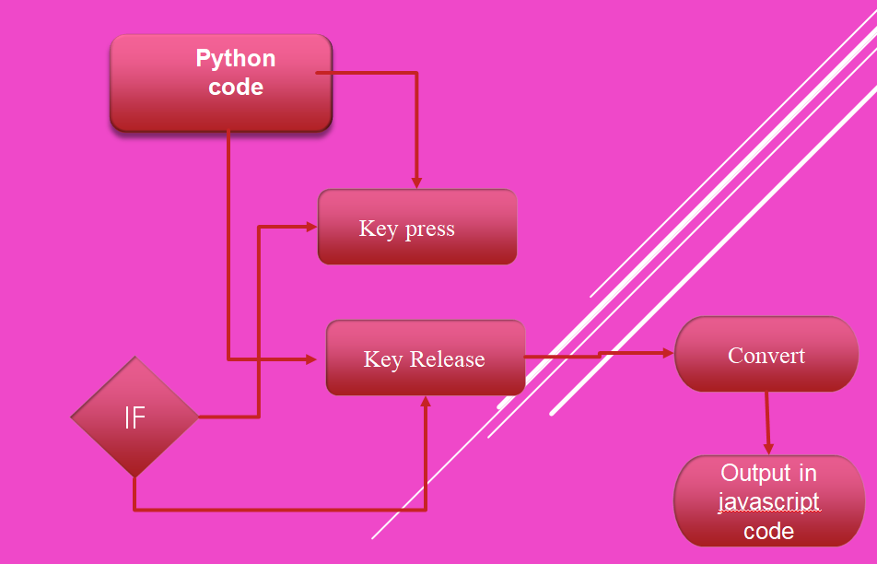

**Design:**

1. **Graphical User Interface (GUI):**

* **Components:**
* Text display area for the given prompt
* Input area for users to type the text of Python code.
* Real-time analytics dashboard showing WPM, accuracy, and progress graphs.
* Gasification elements like score, levels, and badges displayed on the interface.

**2.Real-time Analytics Module:**

**Components:**

* + Analytics engine for calculating WPM and accuracy in real-time.
  + Dynamic updating of performance metrics on the analytics dashboard.
  + Historical data storage for tracking and displaying progress trends.

**Coding:**

import tkinter as tk

from tkinter import scrolledtext

def python_to_javascript():

python_code = python_code_text.get("1.0", tk.END)

javascript_code = python_code.replace("print", "console.log")

javascript_code_text.delete("1.0", tk.END)

javascript_code_text.insert(tk.END, javascript_code)

# Create the main window

root = tk.Tk()

root.title("Code Converter")

# Create the input Python code text area

python_code_label = tk.Label(root, text="Python Code:")

python_code_label.pack()

python_code_text = scrolledtext.ScrolledText(root, wrap=tk.WORD, width=40, height=10)

python_code_text.pack()

# Create the "Convert" button

convert_button = tk.Button(root, text="Convert", command=python_to_javascript)

convert_button.pack()

# Create the output JavaScript code text area

javascript_code_label = tk.Label(root, text="JavaScript Code:")

javascript_code_label.pack()

javascript_code_text = scrolledtext.ScrolledText(root, wrap=tk.WORD, width=40, height=10)

javascript_code_text.pack()

# Run the Tkinter event loop

root.mainloop()

**Testing:**

1. **Functional Testing:** 
   * Objective: Verify that the system functions correctly.
   * Tasks:

Test the accuracy of WPM and accuracy calculations.

Validate the responsiveness and accuracy of user input validation.

**2. User Acceptance Testing (UAT):**

* + Objective: Ensure the system meets user expectations.
  + Tasks:

Engage real users to perform typing tests and provide feedback.

Evaluate user satisfaction with the GUI, gasification elements, and overall learning experience.

**Implementation:**

* Use a Python parser library (e.g., a module) to parse Python source code and generate an Abstract Syntax Tree (AST).
* Traverse the AST to extract relevant information about the structure, syntax, and semantics of the Python code
* Create a mapping mechanism to convert Python language constructs to their equivalent JavaScript counterparts.
* Handle data types, control structures, functions, and other language-specific features to ensure accurate translation.

**Final output:** 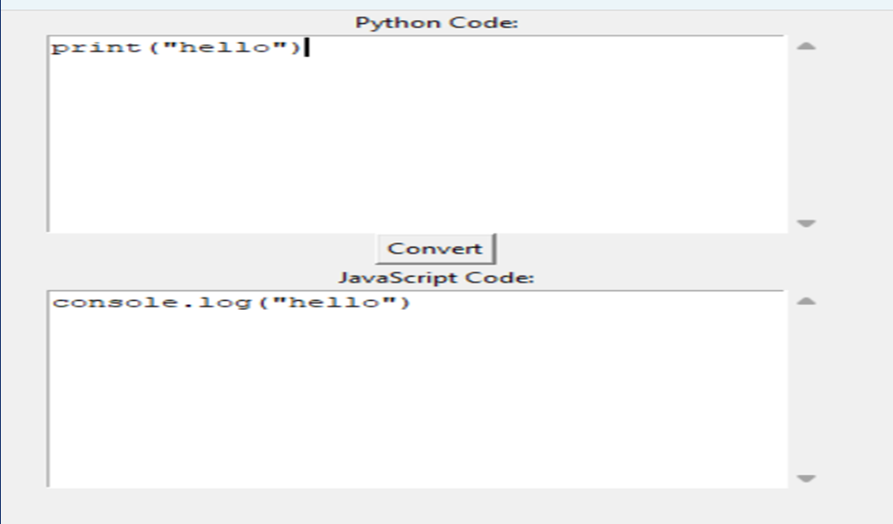

**Conclusion:**

In conclusion, the Code Converter offers an effective and user-centric solution for individuals seeking to enhance their typing proficiency. The combination of accurate metrics, a well-designed interface, and real-time feedback positions this tool as a valuable asset in the digital age. The code converter project successfully combines functionality, usability, and reliability to provide various tools for users seeking to improve their conversion of code. As user demand, the system can easily accommodate increased usage without compromising performance.

**References:**

* + Check official documentation and tutorials for programming languages involved in the conversion. For Python, visit Python Documentation, and for JavaScript, check MDN Web Docs.
  + Search academic databases like Google Scholar for research papers related to code conversion, language translation, or compiler design. Academic publications can provide insights into the underlying algorithms and methodologies